Information on tourist spots around Ojiya

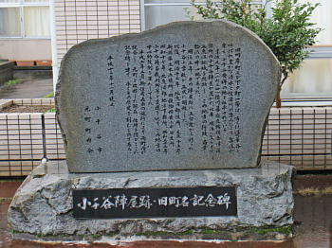
The Site of Ojiya Jinya

Jinya was an administrative headquarter of a smaller feudal domain; Ojiya Jinya was the administrative headquarter of the Aizu domain. Jinya had authority to carry out various duties: collecting tax which was rice from citizens, inspecting the collected rice, developing new rice fields, maintaining banks, making a family register, holding a trial, etc.

When the new government domain was on their way to attack the Aizu domain and the Nagaoka domain, 500 soldiers from the Aizu domain came to Ojiya with cannons. In order to combat and attain victory, they had conducted series of military trainings at riversides and Mt. Funaoka. A lot of villagers were watching the trainings.

In 1868, after the Aizu domain was defeated in the battle of Yuki-Tōge in Uonuma, all the soldiers who were in Jinya was routed, and Jinya became empty.

